Birmingham's Red Mountain Park expected to bring $22.4 million a year to area economy
Published: Friday, March 11, 2011, 8:30 AM
By Michael Tomberlin -- The Birmingham News
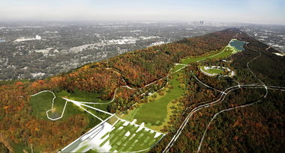The development of Red Mountain Park will add walking and biking trails as well as a 22-acre fishing and paddle boat lake, meadows, pavilions and educational exhibits that celebrate the property's history as a mine and mining camps. (Special)
It may appear the 1,200 acres atop Red Mountain stopped contributing to the Birmingham economy when the last mine closed in 1971. But officials behind the planned Red Mountain Park believe the property's future will boost the region's quality of life, drive surrounding development and pump up property values in some of western Birmingham's poorest neighborhoods.
A study Red Mountain Park commissioned last year by Cambridge, Mass.-based ConsultEcon Inc. found the park project will have a $22.4 million annual economic impact, including $7.6 million in wages, and generate a total of 309 jobs in the metro area. During the construction phase, a one-time economic impact of $176.2 million in spending, including $58.3 million in wages is expected with about 1,700 direct and indirect jobs supported.
"The economic impact the park can have on this community is most thrilling," said David Dionne, executive director of Red Mountain Park.
To get to that point, the park itself has to become a reality. The full development of Red Mountain Park's plans will cost $47 million, but officials are focusing on a more obtainable $17.5 million first phase to create some of the most essential attractions and get the park open to the public.
That $17.5 million is the goal of Red Mountain Park's current capital campaign, which is trying to raise funds from the public through an interactive website as well as through corporate and government donations and support from the Community Foundation of Greater Birmingham and others.
"What we're looking to create is an amenity for not only this region, but the entire state," Dionne said. "Not only will it have a significant economic impact, but recreation and parks are important economic development tools."
Experts agree.
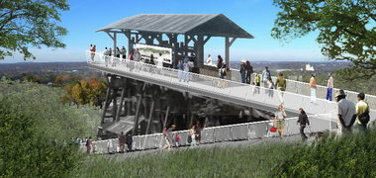Much of the work on the $17.5 million first phase of Red Mountain Park will center on attractions tied to Mine No. 10, including an overlook of Jones Valley. (Special)
Peter Harnik, director of the Trust for Public Land's Center for City Park Excellence in Washington, D.C., told Red Mountain Park supporters Wednesday during a visit to Birmingham that there are numerous examples around the country of urban parks that have boosted quality of life and have even been factors in luring new companies to a city.
Harnik said one of the reasons Boeing Corp. chose Chicago for its corporate headquarters over Dallas was the Windy City's park system, a loss that has since prompted Dallas to focus on its own park infrastructure.
Red Mountain Park officials believe the potential for surrounding development is so great, the park itself wants to purchase around 300 acres that border park property to the south. Currently owned by USS Real Estate, Red Mountain Park wants to develop the property into a mix of uses from commercial to residential and with affiliations from everyone from bike training enthusiasts to the Boy Scouts of America.
According to the ConsultEcon study, the development and operation of surrounding properties at Red Mountain Park will have an annual impact of $18.1 million in expenditures, $4.8 million of which will be in wages. Another 269 jobs will be supported in the Birmingham area by that development. During the development of that land, $322 million in construction spending is expected, including $103 million in wages and salaries, and a total of more than 3,100 direct and indirect jobs will be supported.
That's what USS Real Estate Inc. is hoping for, according to Tom Howard, head of Southeast development for USS Real Estate. The property ownership and development arm of U.S. Steel is the largest property owner in Jefferson County and still owns around 600 acres in the Lakeshore corridor that is undeveloped.
The 1,200 acre tract for Red Mountain Park is former USS land.
"The park will be a big boost," Howard said. "People like to live next to parks and for businesses to have an amenity like Red Mountain Park nearby is certainly an attraction."
Howard said he expects the park will spur development and increase property values all along the corridor and boost USS Real Estate's plans for commercial and residential development in the corridor.
USS owns an industrial park with most of its 100 acres available for companies. USS sold 106 acres to Dollar General, which is planning a $60 million, 1 million-square-foot distribution center, which will create 650 jobs.
Park officials believe that neighborhoods to the north the park -- such as the Spaulding, Ishkooda, Powderly, Garden Highlands, Tarpley City and Wenonah neighborhoods -- could see property values jump 3 to 5 percent after the park is developed.
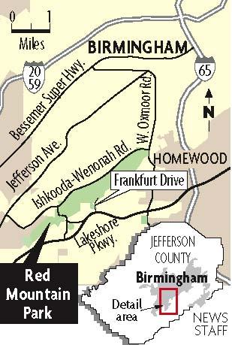View full size
From a tourism standpoint, Red Mountain Park is expected to draw an average of more than 532,000 people per year to attend everything from cross-country running competitions to those looking for a day of zip lining or just having a picnic.
An eight-mile trail will make a loop around the top of the mountain through the park property. Other space will be used for more than 20 miles of trails for hiking and biking. Nearly 50 acres of open meadows will create possibilities for amusement, entertainment and relaxation. A 22-acre fishing and paddle sports lake will also be a part of the project.
The park will have historical attractions that center on the shaft mine, 10 slope mines and hundreds of drift mines that once covered the mountain. The three former mining camps that were once part of the area will also be commemorated.
Thousands of black and white workers labored for 108 years to pull an estimated 305 million tons of iron ore out of the ground at the site. Now park officials are convinced those mines and the rest of the property will contribute once again to the area's economy.
Birmingham News staff writer Thomas Spencer contributed to this report.
Join the conversation by clicking to comment or e-mail Tomberlin at mtomberlin@bhamnews.com.

