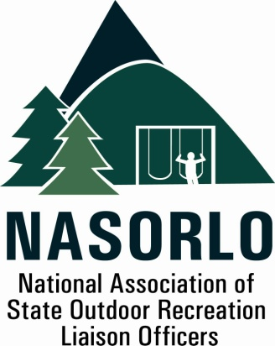

President
Tim Hogsett
Texas

Vice President
Susan Moerschel
Delaware
Secretary
Linda Lanterman
Kansas

Past President
Domenic Bravo
Wyoming

Executive Director
Doug Eiken
Missouri

Board of Directors

John Beneke
Arkansas

Steve DeBrabander
Michigan

Ben Ellis
Alaska

Phil Gaines
South Carolina

Doug Hofer
South Dakota

Craig Wacker
Nebraska

Lauren Imgrund
Pennsylvania

Sedrick Mitchell
California

Gerald Parish
Tennessee

Jennifer Scanland
Nevada

Dan Schuller
Wisconsin

105H, ABNR BUILDING
UNIVERSITY OF MISSOURI
COLUMBIA, MO 65211-7230

573.353.2702 P
573.882.9526 F
nasorlo@gmail.com

www.nasorlo.org

November 25, 2015

NASORLO Resolution

PREAMBLE

The National Association of State Outdoor Recreation Liaison Officers (NASORLO), official appointees of the States’ Governors, administer the federal Land and Water Conservation Fund Stateside Program (LWCF) throughout the United States and US Territories. Actions by current and past NASORLO members have resulted in protected parks in every geographic region of the United States, every county, nearly every city or town, and territory. Since 1965, approximately 2.6 million acres of park and conservation lands have been preserved in perpetuity while outdoor recreation opportunities grew at 29,000 locations across our country.

WHEREAS, over the past 50 years the LWCF Act created to one of the most successful federal/state OUTDOOR RECREATION partnerships in history, which stimulated hundreds of millions of dollars from private, local and state sources matching federal funds for outdoor recreation projects;

WHEREAS, the National Association of State Outdoor Recreation Liaison Officers (NASORLO), representing the states and territories, and liaisons to Congress and the Department of Interior, met on September 25, 2014 in Vancouver, Washington, for purposes of discussion of the reauthorization of the Land and Water Conservation Act;

WHEREAS, on September 3, 1964, President Lyndon Johnson, signed into law the Land and Water Conservation Fund Act, passed by the United States Congress, to provide urban and rural outdoor recreation opportunities on state, federal and local lands for all Americans. When the Act was passed by Congress its primary purpose was to provide outdoor recreation for Americans in close to home locations, guaranteeing that sixty percent (60%) of the Act’s funds were to be dedicated to the states and territories;

WHEREAS, the Act was later amended to eliminate the 60% guarantee of the state’s LWCF share, though, with guarantees of not less than 40 percent of annual appropriations for federal LWCF project purposes;

WHEREAS, over 40,000 grants to states and localities were awarded LWCF State Assistance Grants Program funds for acquisition, development and planning of outdoor recreation opportunities. These grants represent an investment of $4.2 billion in LWCF assistance, matched with private, local and state sources representing a minimum $8.4 billion local investment resulting in the creation of state and local parks that continue today to provide close-to-home recreation opportunities readily accessible to America's youth, adults, senior citizens and the physically or mentally challenged;

WHEREAS, the Land and Water Conservation Fund Act will expire in September 2015, and assessments by the National Park Service show significant unmet needs for outdoor recreation in state, local and urban areas;

WHEREAS, NASORLO looks forward to working with all interested stakeholders, including the nation's Governors, Congress and the Administration to create a mutually agreeable platform and strategy to achieve the legislative reauthorization, and, fairness and equity for the state share of the LWCF assistance; and

WHEREAS, the members of NASORLO and our stateside partners reinforce our strong and enthusiastic support for legislation that would enhance the Land and Water Conservation Fund;

NOW, THEREFORE, BE IT RESOLVED, NASORLO requests that Congress reauthorize the Land and Water Conservation Fund Act and restore language that includes full and permanent funding and not less than a 40% share of the LWCF allocation EXCLUSIVELY for OUTDOOR RECREATION GRANTS THROUGH the State Assistance Program.

Signed: __________________________________________________, President NASORLO
Tim Hogsett, President

