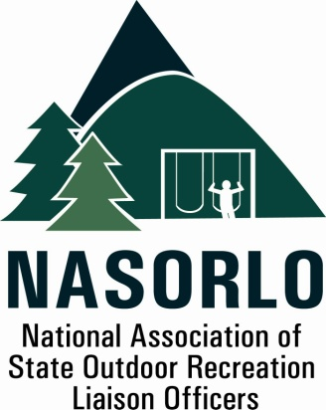

President
Tim Hogsett
Texas

Vice President
Susan Moerschel
Delaware
Secretary
Linda Lanterman
Kansas

Past President
Domenic Bravo
Wyoming

Executive Director
Doug Eiken
Missouri

Board of Directors

John Beneke
Arkansas

Steve DeBrabander
Michigan

Ben Ellis
Alaska

Phil Gaines
South Carolina

Doug Hofer
South Dakota

Craig Wacker
Nebraska

Lauren Imgrund
Pennsylvania

Sedrick Mitchell
California

Gerald Parish
Tennessee

Jennifer Scanland
Nevada

Dan Schuller
Wisconsin

105H, ABNR BUILDING
UNIVERSITY OF MISSOURI
COLUMBIA, MO 65211-7230

573.353.2702 P
573.882.9526 F
nasorlo@gmail.com

www.nasorlo.org

Executive Director Report to the Membership,
Greenville SC, September 8, 2015

This has been an exciting year, with the reauthorization of LWCF with an equitable State Assistance Program as NASORLO's highest priority. This potential action has driven NASORLO's and my priorities for the past three years and seems to be coming to a conclusion soon.

I think we have seen successes in expanding our Stateside Coalition and working with and involving the National Governor's Association in our efforts. Some disappointments are the continued lack of support and involvement from some of our key states and, even though we have made extensive efforts to do so, not receiving support from the Department of Interior for improving the funding levels for the state programs.

Here is a quick summary of some my key activities since the last annual meeting.

Stateside Coalition. We have been actively engaged to expand the Coalition to include those entities that could benefit greatly from an improved grant program. They include the core group of NRPA, NASPD, NGA and the City Parks Alliance. We have also been engaged with the American Planning Association, Nat. Assn. of Counties and their Park administrators, plus Mayors for Parks and CDC. We seek consensus on communications with Congress and to restore adequate funding for grants to cities, local communities, state and regional parks. ( See the Resolution passed at our last meeting and distributed throughout this year to key decision makers) The result is that our message is being heard and recognized and we are players in the discussions over reauthorization of LWCF.

NASORLO Tool Kit. We have prepared, and posted on the NASORLO website, key information, draft letters and supporting materials for state advocates could keep abreast of the changing thoughts on LWCF reauthorization and take action consistent with NASORLO and the Coalition. In addition, any letters of support, or articles about reauthorization and the importance of state grants, have also regularly been posted with the Tool Kit materials and made available on line. NRPA has also prepared a tool kit with updated data sheets for each state ( NASORLO's and the OIA's economic data are also provide ), so that the best possible argument can be made when contacting elected officials about LWCF.

Budget. In each of the last three years, NASORLO has been seeking to hold the line on expenditures, while ensuring the funds we do have are directed to the reauthorization and training for our members. As you can see from the 2014 Fiscal Summary we had 42 states and territories paying dues for many reasons beyond our control, we needed to draw down the NASORLO reserve fund in each of the last three years. We felt we needed to do this to be as active as we could be in the dialogue concerning reauthorization, so expenditures were made for travel, awards, and other activities which support LWCF reauthorization as a priority. We are in good financial shape at this time, but at some point in the future, either expenditures will need to be reduced, or an effort made to get all states and territories in a paid up status, or consideration given to a dues increase.

Outdoor Recreation Legacy Program. ( ORLP ) This new program was implemented within the past year. We were involved with NPS over the past two years finding ways to publicize the program, help them with developing criteria and advising them on the roll out. Delays inherent in the program were frustrating for NPS staff and the Association, but we feel it did result in good grants and sets a standard for future ORLP funding in the future.

Training. Our recent survey and comments from last years annual meeting pointed out the need for a better focus on training. We have been encouraging NPS to provide regular training for LWCF staff and they did this year in Omaha. In addition, we have placed training in this year's annual meeting as a key component. With all the recent focus on reauthorization, this is another area that will continue to be a high NASORLO priority in the future.

