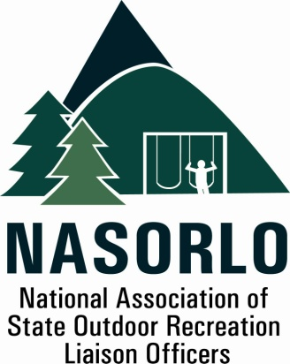

www.nasorlo.org

President
Susan Moerschel
Delaware

Vice President
Lauren Imgrund
Pennsylvania

Secretary
John Beneke
Arkansas

Past President
Tim Hogsett
Texas

Executive Director
Doug Eiken
Missouri

Board of Directors
Kaleen Cottingham
Washington

Steve DeBrabander
Michigan

Linda Lanterman
Kansas

Phil Gaines
South Carolina

Doug Hofer
South Dakota

Craig Wacker
Nebraska

Erika Rivers
Minnesota

Sedrick Mitchell
California

Gerald Parish
Tennessee

Jennifer Scanland
Nevada

Craig Whipple
Vermont

Danette Poole
Virginia

105H, ABNR BUILDING
UNIVERSITY OF MISSOURI
COLUMBIA, MO 65211-7230
573.353.2702 P
573.882.9526 F

NASORLO 2016 Annual Business Meeting Agenda, September 21-22, 2016
Downtown Marriott, Detroit, MI

Welcome and Roll Call – President Susan Moerschel
Approval of Minutes from the 2015 Annual Meeting ( Attachment A )
Fiscal Reports - Eiken
  - 2015 Year End Summary ( Attachment B )
  - 2016 Budget Update ( Attachment C )
  - Dues proposal - Sec/Treasurer Beneke ( Attachment D )
NASORLO Reports
a. Organizational Report - President Moerschel/Eiken ( Attachment E )
b. Nominations Committee Report - Hogsett
c LWCF Modernization Committee Report – Imgrund ( Attachment F )
d LWCF Geospatial Database - President Moerschel, Dee Merriam and Larry Orman ( Attachment G )
e. 2017 Annual Program Committee Report - Lanterman
f. NASORLO Partners Reports
NRPA - David Tyahla
Reauthorization
Appropriations
New Conservation Legislation proposal
NASPD - Lewis Ledford
Action Items
Election of Board Members
Dues Proposal ( Attachment D )
Adopt Priorities and Agenda for 2017
GOMESA
Reauthorization
NPS Modernization
Other Business
Closing Comments - President Moerschel
Adjourn

