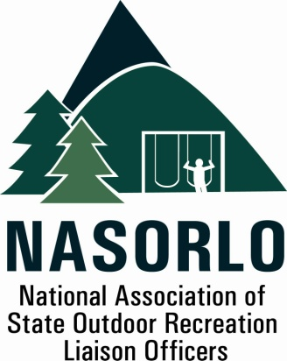

www.nasorlo.org

President
Susan Moerschel
Delaware

Vice President
Lauren Imgrund
Pennsylvania

Secretary
John Beneke
Arkansas

Past President
Tim Hogsett
Texas

Executive Director
Doug Eiken
Missouri

Board of Directors
Kaleen Cottingham
Washington

Steve DeBrabander
Michigan

Linda Lanterman
Kansas

Phil Gaines
South Carolina

Doug Hofer
South Dakota

Craig Wacker
Nebraska

Erika Rivers
Minnesota

Sedrick Mitchell
California

Gerald Parish
Tennessee

Jennifer Scanland
Nevada

Craig Whipple
Vermont

Danette Poole
Virginia

105H, ABNR BUILDING
UNIVERSITY OF MISSOURI
COLUMBIA, MO 65211-7230
573.353.2702 P
573.882.9526 F

2016 Key Priorities

- Urge Congress to restore the balance in the state/federal LWCF allocation providing long-term certainty and stability for a program benefiting every state
- Specifically, seek longer term Program authorization beyond the current three year period, and, seek at least 45% of LWCF apportionments for the state and local park development and acquisition – originally established as the Stateside Assistance Program
- Emphasize the value of LWCF investments in communities
- Expand the LWCF stateside coalition
- Advocate for federal administrative program sustainability ( increased staff and funding for NPS program )
- Strengthen the NASORLO-NPS relationship to better meet programmatic challenges, improve program efficiency/productivity
- Hold an Annual Program & Meeting in Detroit, Michigan focused on LWCF knowledge transfer
- Recruit and retain key NASORLO members for the Board and Executive Committee
- Evaluate website usage and make timely information uploads and improvements
- Secure funding for completion of the LWCF Atlas with a publicly accessible/user friendly interface
- Improve LWCF training for NASORLO member

Summary of Actions and Accomplishments September 2015 to 2016

LWCF Advocacy & Reauthorization
- Overview: Telephone conference calls each month organized by Doug Eiken with partners – NRPA, NASPD, APA, CPA – strategizing on bill status, Congressional positions, planning responses and meetings.

- November 2015 – Capitol Hill, Washington, DC. Susan Moerschel (DE) and Lauren Imgrund (PA) with David Tyahla, NRPA, visits.

- Wednesday, November 18, 2015 - House Natural Resources Committee Hearing entitled, "Protecting America's Recreation and Conservation Act" Discussion Draft – offered by Cong. Rob Bishop, (R-Utah), Chair, House Natural Resources Committee.

- Bill Bryan – Missouri State Park Director, and SLO, testified. Moerschel and Imgrund attended. Eiken audited via internet and cell phone.

