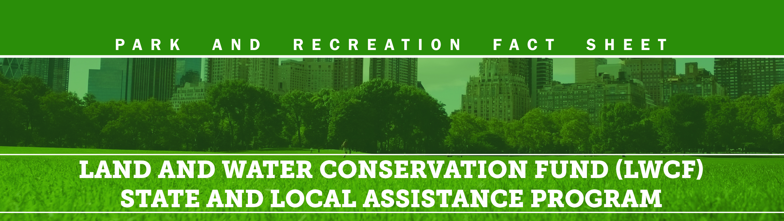
BACKGROUND
In 1965, the Land and Water Conservation Fund (LWCF) was enacted to help preserve, develop and ensure access to outdoor recreation facilities for the purpose of strengthening the health of U.S. citizens.
Congress created LWCF to meet the nation’s growing need for access to close-to-home outdoor recreation. The money for the fund comes not from taxes, but primarily from oil and gas lease revenues derived from federal lands. This helps balance the environmental impacts associated with resource extraction by ensuring that new parks and open spaces are accessible to all Americans.
Lasting Impact on Local Economies and Quality of Life
The LWCF State Assistance Program requires states and local communities to match the federal investment dollar-for-dollar. Since 1965, the LWCF State Assistance Program has:
- Provided over $4 billion to states, territories and local communities. Combined with the local match, LWCF State Assistance funds have yielded a total investment of more than $8 billion.
- Funded more than 42,000 local and state projects in 98% of local counties in America.
- Protected three million acres to provide close-to-home public outdoor recreation accessible to all Americans.
That Continued Impact is At-Risk
- From 1965–1976, 60 percent of LWCF appropriations went to the State Assistance Program.
- Since 1988, less than 15 percent of total LWCF appropriations have gone to the State Assistance Program.
NRPA POLICY POSITION
- Support the permanent reauthorization of the LWCF, including full and dedicated funding. LWCF is scheduled to expire in October 2018.
- Require a minimum of 40 percent of the total annual LWCF funding be allocated to the LWCF State Assistance Program - the same amount required by law to be allocated for LWCF federal land acquisition.
- In absence of authorizing legislation, exercise discretionary appropriations authority to allocate at least 40 percent of the total LWCF funding in FY18 to the State Assistance Program. This includes robust funding for the Outdoor Recreation Legacy Partnership (ORLP) urban competitive program.
WHY CONGRESS SHOULD ACT
Creating Jobs and Stimulating the Economy
The outdoor recreation industry is one of the nation’s most important economic drivers.
- The LWCF State Assistance Program supports our nation’s local and regional parks, which create nearly $140 billion in economic activity and support almost 1 million jobs in the United States.¹
- Active outdoor recreation contributes $887 billion annually to the economy, supporting 7.6 million jobs, as well as generating nearly $125 billion in federal, state and local tax revenue.²
- More American jobs depend on trail sports (768,000) than there are lawyers (728,000) in the U.S. ²
- Americans spend more annually on cycling and skateboarding ($91 billion) than they do on home entertainment, movie theater tickets, and video games, combined ($90 billion). ²
- The 791 million visitors to America’s state park system in 2016 — a recipient of LWCF State Assistance funding — represent more than twice the total population of the United States. (3)
Every State and Territory Annually Receives Funding
States do not have to compete against other states for funding. Each year, a set percentage of LWCF State Assistance funding is equally distributed to the states and territories. Remaining funds are then allocated based on population.
Available To and Used By Every American
While not every community has a national park, every community has local outdoor recreational resources. These parks are used by people of all ethnic groups, all income levels and all ages on a daily basis throughout the year. LWCF State Assistance funding ensures close-to-home public recreation resources with parks and projects located in 98% of all counties in America.

“Protecting America’s parks, waters and trails isn’t just about the land. It’s about protecting the economy, the communities and the people whose lives depend on having the ability to play outside.”
-Outdoor Industry Association

Wise Use of Federal Funds at NO Expense to the U.S. Taxpayer
- LWCF has a dedicated revenue source. For nearly five decades, LWCF has been funded by Outer Continental Shelf (OCS) offshore oil and gas leasing revenues. NOTE: To date, unappropriated OCS revenues intended for LWCF exceed $20.5 BILLION.(4)
- States and localities are required to match federal funds dollar-for-dollar. This doubles the investment in state and local park and recreation projects, thereby creating more jobs.
- Land used for LWCF State Assistance projects must remain in recreational use in perpetuity. This ensures that the federal, state and local investments remain available for future generations of Americans.
NOTE: Final FY17 Consolidated Appropriations Act approved May 1, 2017, includes $400m in overall funding for the LWCF, with State Assistance receiving a total of $110m, again including $12m for the ORLP program.
FISCAL YEAR | TOTAL LWCF* | LWCF State Assistance | Percentage of Total LWCF | Amount State Assistance Would Have Received with a 40% Allocation
FY13 | $305,479,000 | $39.934,400 | 13.1% | $122,192,000
FY14 | $305,043,000 | $45,000,000* | 14.7% | $122,417,000
FY15 | $306,100,000 | $45,000,000* | 14.7% | $122,417,000
FY16 | $450,000,000 | $110,000,000** | 24.4% | $180,000,000
1 Source: National Recreation and Park Association /
George Mason University 2015
2 Source: Outdoor Industry Association 2017 3 Source: National Association of State Park Directors 4 Source: Congressional Research Service 2016
* In FY14 and FY15 LWCF State Assistance funding totaled $45m, which included $42m in formula grants to the states and $3m in “competitive” ORLP grants. ** In FY16 LWCF State Assistance funding totaled $45m, which included $94,839,000 in formula grants to the states and $12m in “competitive” ORLP grants.

(Date: June 2017)

