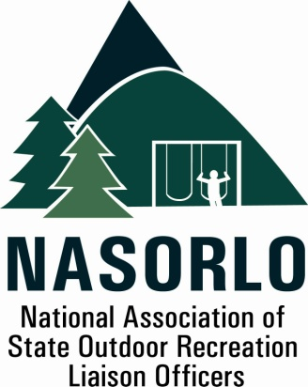

President
Lauren Imgrund
Pennsylvania

Vice President
Linda Lanterman
Kansas

Secretary
Vacant

Past President
Vacant

Executive Director
Doug Eiken
Missouri

Board of Directors

Randy Kittle
South Dakota

Melissa Baker
North Dakota

Erika Rivers
Minnesota

Jennifer Gihring
Wisconsin

Eric Feldbaum
New Hampshire

Mick Rogers
Arizona

Dana Lagarde
Texas

John Beneke
Arkansas

Antoinette Norfleet
Georgia

Sedrick Mitchell
California

Gerald Parish
Tennessee

Doug Beck
Maine

105H, ABNR BUILDING
UNIVERSITY OF MISSOURI
COLUMBIA, MO 65211-7230
573-353-2702

NASORLO 2019 Annual Business Meeting Agenda,
October 8-11, 2019, Reno NV

Welcome and Roll Call – President Lauren Imgrund
I. Minutes from the 2018 Annual Meeting ( Attached - White )
II. Fiscal Reports - Eiken
  - 2018 Year Fiscal Summary ( Pink Attachment )
  - 2019 3rd Quarter Fiscal Summary ( Green Attachment )
III. NASORLO Reports
a. Annual Report - President Imgrund/Eiken
( Yellow Attachment )
b. Report on Congressional Action Update
Kyle Simpson ( NRPA ) President Imgrund
c. Partners Report
NPS - Joel Lynch
NASPD - Lewis Ledford, Exec. Dir. and Linda Lanterman, President
NRPA - Kyle Simpson
d. Nominations Committee Report - Randy Kittle
e. LWCF Modernization Committee Report – Doug Beck
( White - Attachment - Summary and White Papers)
f. Awards Committee Report - Gerald Parish
g. 2020 Annual Meeting Invitations and Options
IV. Action Items
a. Election for Officer and Board Vacancies
b. Review 2020 Priorities
Action on any proposed LWCF Modernization efforts
2020 LWCF Resolution
c. 2019 Annual Meeting Decision
V. Other Business
VI. Closing Comments - Incoming NASORLO President
VII. Adjournment:

