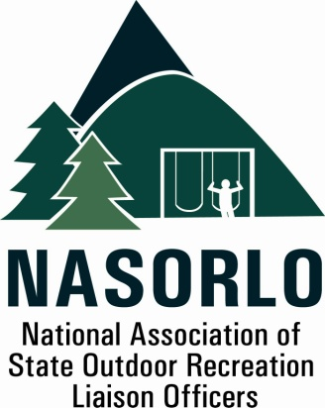

President
Lauren Imgrund
Pennsylvania

Vice President
Linda Lanterman
Kansas

Secretary
Vacant

Past President
Vacant

Executive Director
Doug Eiken
Missouri

Board of Directors

Randy Kittle
South Dakota

Melissa Baker
North Dakota

Erika Rivers
Minnesota

Jennifer Gihring
Wisconsin

Eric Feldbaum
New Hampshire

Mick Rogers
Arizona

Dana Lagarde
Texas

John Beneke
Arkansas

Antoinette Norfleet
Georgia

Sedrick Mitchell
California

Gerald Parish
Tennessee

Doug Beck
Maine

105H, ABNR BUILDING
UNIVERSITY OF MISSOURI
COLUMBIA, MO 65211-7230
573-353-2702

NASORLO Crossroads - 5 Year Strategic Planning

As stewards of the LWCF State Assistance Program, it is important that we continue to assess the condition of that program, and our role and structure as an organization of Governor appointed liaisons to the program. Recent events, including permanent reauthorization of the Land and Water Conservation Act, and a guarantee of 40% funding for States, as well as the dramatic increases in GOMESA guaranteed funding are very historic and welcomed developments.

Your Board of Directors feels that this is a good time to do some strategic planning and setting of priorities for NASORO so that we remain relevant as an organization, and serve your needs as LWCF State Assistance administrators. We plan to start that process in a planning session at the annual conference next month in Reno.

In order to use the time in Reno for maximum efficiency, we are asking each of you to do a little homework in preparation. The first is for you to review the current NASORLO Mission Statement, and come prepared to comment on its relevance, and with suggestions for needed changes.
Our Mission: We are the primary advocate for the State Assistance program of the Land and Water Conservation Fund. We do this through providing information, training, collecting data and preparing reports for use by the Department of Interior, Congress, our members, partners and communities who benefit from this program. ( Note the key words.. Advocate, providing Information, Training, Data Collection, Reports..) Others ?
Next, we would like for each of you to assess your current situation as individual LWCF state administrators and prepare a list of needs and issues you believe NASORLO should focus on for the next several years. Please think not only locally about your needs and desires for our organization, but also how our organization as a national force can make LWCF a better conservation and recreation program.

To stimulate your thinking, a list of possible priorities is offered below. This list is based on some of the past issues and priorities we have worked with as an organization.
Past Priorities to stimulate your thinking:

A. LWCF administration information exchange,
B. LWCF administration training at Annual Meeting,
C. Annual Meeting LWCF site tours,
D. Review of, and administrative changes needed in federal LWCF Manuals,
E. Best park practices exchange, Best administrative practices exchange
F. Mapping of LWCF assisted sites and associated 6(f)3 boundaries on a sharable database
G. Partnership with NASPD, Advocacy for State Assistance Program at Federal and State levels
H. Groundbreaking and park dedication best practices

For those of you that can’t be in Reno, we welcome your written suggestions on these topics via e-mail prior to the meeting so your views are considered. The desired outcome of the Reno general session on this topic is the draft of an updated mission statement and a prioritized list of possible future directions for our Board of Directors to consider,
Thank you for your participation in this important process!
Tim Hogsett, Past President and Planning Facilitator

