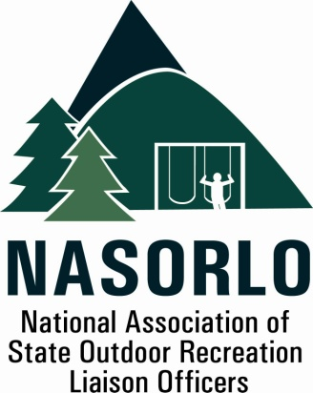

President
Lauren Imgrund
Pennsylvania

Vice President
Linda Lanterman
Arkansas

Secretary
Jan Hunt
Oregon

Past President
Tim Hogsett
Texas

Executive Director
Doug Eiken
Missouri

Board of Directors
Kaleen Cottingham
Washington

Melissa Baker
North Dakota

Erica Rivers
Minnesota

Mary Fitch
Ohio

John Beneke
Arkansas

Eric Feldbaum
New Hampshire

Doug Beck
Maine

Amy Blinson
South Carolina

Gerald Parish
Tennessee

Sedrick Mitchell
California

Sue Black
Arizona

105H, ABNR BUILDING
UNIVERSITY OF MISSOURI
COLUMBIA, MO 65211-7230
573.353.2702 P

September 17, 2018
The Honorable Rob Bishop, Chairman
Natural Resources Committee
U. S. House of Representatives
Washington, DC 20515

The Honorable Raul Grijalva, Ranking Member
Natural Resources Committee
U. S. House of Representatives
Washington, DC 20515

Dear Chairman Bishop and Ranking Member Grijalva:
We are writing to express our strong support for the Land and Water Conservation Fund (LWCF) State and Local Assistance and the Outdoor Recreation Legacy Partnership (ORLP) Programs administered by the Department of Interior. NASORLO represents the state and territorial officials, appointed by our Governors, who serve as the liaisons to Interior in the administration and advocacy for the LWCF State Assistance. LWCF grants for state, local and urban projects improve and expand outdoor recreation opportunities at close to home locations in every state. We thank you for your strong support of the State and Local LWCF Program.
Specifically, we are supportive of the recent action on HR 502 which would permanently reauthorize the Land and Water Conservation Fund and provide a guaranteed 40% share of funds for the State and Local Assistance Program. NASORLO has long sought this equity in appropriations for the State and Local Assistance and Federal sides of LWCF.
As you know there is a tremendous need for outdoor recreation opportunities and access in the local areas and communities where Americans work and play. The State and Local Assistance Program is the federal government's only investment tool dedicated to the development of close to home public outdoor recreation. HR 502 recognizes these needs and provides a steady stream of funding for state and local recreation assets.
These programs support the economy in significant ways and require at least an equal investment made by the county, city or state grant recipient. A 2017 NASORLO survey found 75% of LWCF projects fund park infrastructure boosting job creation and local economies.

In conclusion, we appreciate your continued support for parks and outdoor recreation in local communities and urban areas as well as in state parks throughout the nation by through permanent re-authorization of LWCF and a guaranteed 40% equity share for the State and Local Assistance Program.
We look forward to working with you on these and other issues of important to the delivery outdoor recreation and healthy lifestyles across this country and in US Territories.
Sincerely,

Lauren S. Imgrund
President

