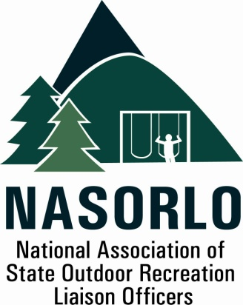

President
Doug Beck
Maine

Vice President
Eric Feldbaum
New Hampshire

Secretary
Janice Keillor
Nevada

Past President
Linda Lanterman
Kansas

Executive Director
Doug Eiken
Missouri

Board of Directors

Randy Kittle
South Dakota

Lauren Imgrund
Pennsylvania

Audrey Mularie
Minnesota

Christie Bayus
Michigan

Mick Rogers
Arizona

Sedrick Mitchell
California

Dana Lagarde
Texas

Brian Stith
Missouri

Justin Hancock
South Carolina

Antoinette Norfleet
Georgia

Megan Duffy
Washington

Robert Ehemann
Delaware

105H, ABNR BUILDING
UNIVERSITY OF MISSOURI
COLUMBIA, MO 65211-7230
573-353-2702

E

2022 Annual Meeting Report to the Membership

President Doug Beck and Executive Director Doug Eiken, October 5th, 2022

Since last years Annual Meeting there have been many challenges and opportunities for NASORLO. The highlights have been establishing NASORLO as a visible advocate for the State Assistance Program and ORLP in DC, as we have been regularly meeting with key congressional staff and the Department of the Interior officials. We have also emphasized and increased our Training efforts for project sponsors, business officials, organizations and NASORLO members in our efforts to improve the administration and use of the LWCF program. The following were our 2022 priorities and an current assessment of their status.

Signal Contract. After the approval of the Membership at last years Annual Meeting to continue the consulting contract with the Signal Group, we have noted several successes. Their work in setting up Congressional staff meetings, preparing draft letters, advice on the timing of contacts with key Committees, setting up meetings with Interior Officials and coordinating NASORLO efforts with other similarly focused non profit organizations based in DC has led to many of the successes listed below. In addition, this year saw a partnership with NASPD to support the Signal contract until the end of April in 2023, therefore allowing us to have an impact upon and input into the FY 24 LWCF budget process and deliberations. NASORLO has a decision to reach about whether we can commit to an extension of this contract beyond April of next year. Any extension will likely require further partnerships, sponsorships and other revenues.

FY 22 and 23 LWCF budgets. In FY 22 we were successful in obtaining a full 40 % of the LWCF, as recommended in the GAOA. However, in the FY 23 Administration Budget and the negotiated House and Senate final budget currently being considered, we fell short of the recommendation, due to the factoring into the 40% calculation, programs that were considered “ state “ conservation grants that were unrelated to outdoor recreation. Defining specifically the 40% recommendation to exclusively be set aside for outdoor recreation grants will be an ongoing priority and challenge for NASORLO.

Administrative Grants. Another of our highest priorities for FY 23 was obtaining authorization to use a portion of the annual LWCF apportionment for state and territorial administration. Through the strong internal support of NPS and our efforts over the past few years in raising this issue and educating LWCF advocates and Congressional staff about this need, we feel certain this provision will be included in the final budget language for the FY 23 budget.

