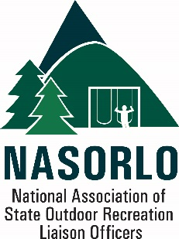
Priorities - LWCF Grants Program
2022 NASORLO LWCF Priorities
- Obtain recommended the full 40% allocation for the State Assistance Program in the FY 23 Budget.

Seek a NPS decision to allow ARA funding to match LWCF for state and local grants

- Stateside Administrative Funding - allow up to 10% annual apportionment to be used in supporting direct and indirect costs of state side program management.

- Conversions / Stewardship

  - Establish a 6(f)(3) boundary advisory committee to assist NPS in resolving issues surrounding indistinct, incomplete or absent boundaries on existing LWCF assisted projects.

  - Delegate authority to states to resolve small conversions and temporary non-conforming use.

  - Establish a 180-day time limit for NPS action on submitted conversions. If no action taken within that period, states will have full authority to resolve conversions and report outcomes to NPS.

  - Liberalize rules related to the use SRA accounts

  - Seek accurate GOMESA estimates in the Budget process.

  - Extend SCORP from 5 - 10 years.

- Reduce match requirement to 20% over the next five years to promote greater access to funds and further promote economic recovery.

- Assure notice of apportionment and facilitate project approvals in a timely fashion and extend the obligation limit of funds from three(3) years to five (5) years to further enable access to and allocation of all available funds.

- Establish a working group comprised of states and NPS leadership to review and make determinations on how to improve program efficiency and effectiveness. The working group should be empowered to work through a LEAN process (or similar program) to identify program in-efficiencies and make permanent structural program changes.

- Work with partners to develop and maintain a retrievable digital data base that identifies all LWCF projects in the nation.

- Continue to work with NPS to facilitate better cooperation and collaboration on LWCF State Assistance grants administration.

